Mnemonic
A mnemonic is defined as "a device, such as a formula or rhyme, used as an aid in remembering."
Examples:
As a child, you might have determined the number of days in a given month by
- Reciting the rhyme "Thirty days hath September, April, June, and November . . . ." or
- Using your knuckles ("peaks" have 31 days and "valleys" have 30, except February, of course).
If you have studied music, you might have used these techniques for remembering the names of the notes:
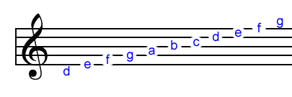
- FACE represents the names of the notes in the spaces on the staff.
- The first letters of the words in sentence "Every good boy does fine" represent the names of the notes on the lines on the staff.
A mnemonic used to recall the steps for simplifying algebraic expressions is "Please excuse my dear Aunt Sally."
- Perform operations within the innermost parentheses and work outward.
- Evaluate all exponential expressions.
- Perform multiplications and divisions as they occur, working from left to right.
- Perform additions and subtractions as they occur, working from left to right.
Refer to a diagram showing the planets of our solar system:
Use the sentence "My Very Educated Mother Just Served Us Nine Pizzas" to recall the order of the planets from the sun. Note that this is prior to the latest controversy about Pluto.
- Mercury
- Venus
- Earth
- Mars
- Jupiter
- Saturn
- Uranus
- Neptune
- Pluto
Refer to a resistor color code chart:
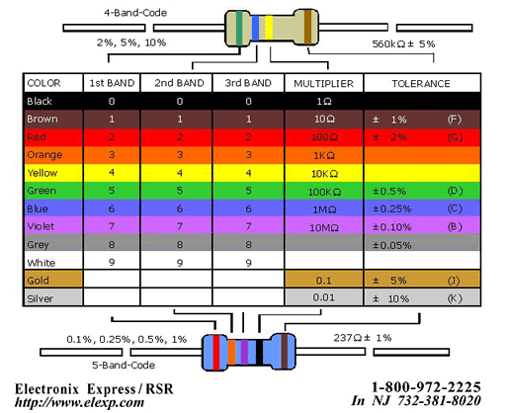
Use this mnemonic:
Big Brown Rabbits Often Yield Great Big Vocal Groans When Gingerly Slapped for the color codes for resistors
- Black
- Brown
- Red
- Orange
- Yellow
- Green
- Blue
- Violet
- Gray
- White
- Gold
- Silver

